

MEHRAN UNIVERSITY

OF ENGINEERING & TECHNOLOGY

JAMSHORO, PAKISTAN

Subject: Software Design and Architecture

(Tasks Solution)

|  |  |
| --- | --- |
| **Roll No:** | **22SW106** |
| **Section:** | **III** |

# **Practical/Lab No. 01**

Introduction to UML and to become familiar with usecase diagrams.

## **Task # 01**

Create a use case diagram for online Human Resource Management system. Show at least two actors and various use cases along with the relationships (extended, include, generalization) between them.

**Solution:**

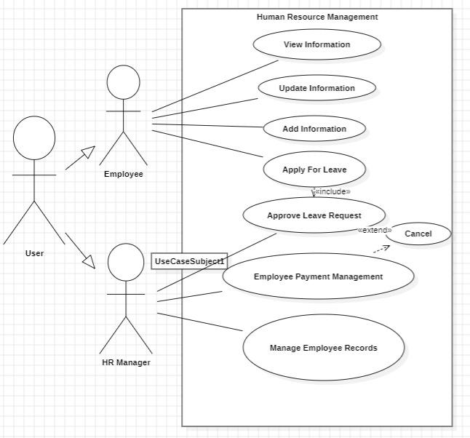

## **Task # 02**

Create a simple use case diagram that identifies the actors involved in a specific scenario. For example, if you are designing a website, the actors may include users, administrators, and developers.

**Solution:**

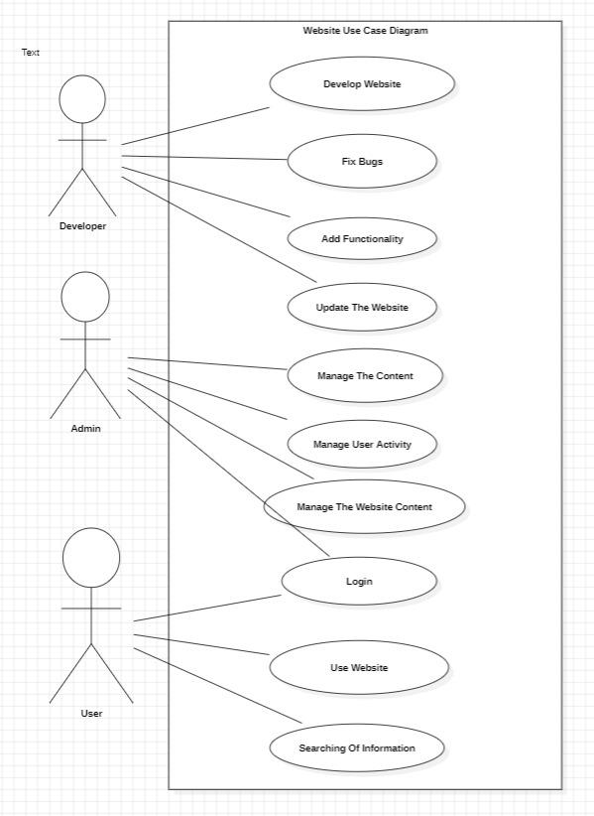

## **Task # 03**

Create a use case diagram that defines the different use cases for a specific scenario. This may involve identifying the different actions that a user can take, such as searching for a product, adding a product to their cart, and checking out.

**Solution:**

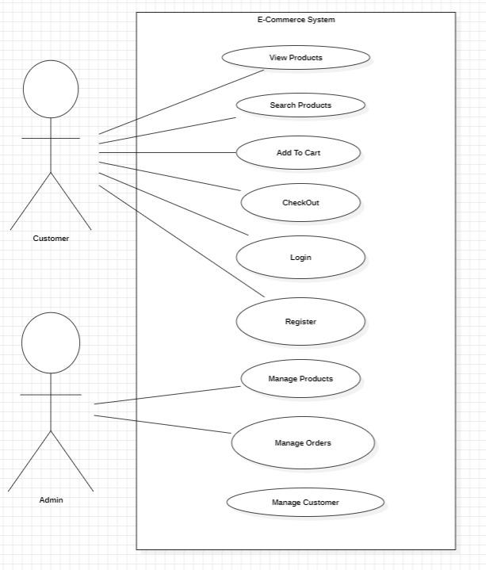

# **Practical/Lab No. 02**

Introduction to UML and to become familiar with usecase diagrams.

**1. Ecommerce System:**

**Description: Design a class diagram for an e-commerce system that includes customers,**

**orders, products, and payments.**

**Relationships:**

**A Customer can place multiple Orders (association).**

**An Order can include multiple Products (composition).**

**An Order has one Payment (aggregation).**

**CreditCardPayment and PayPalPayment are specialized types of Payment (inheritance).**

**Solution:**

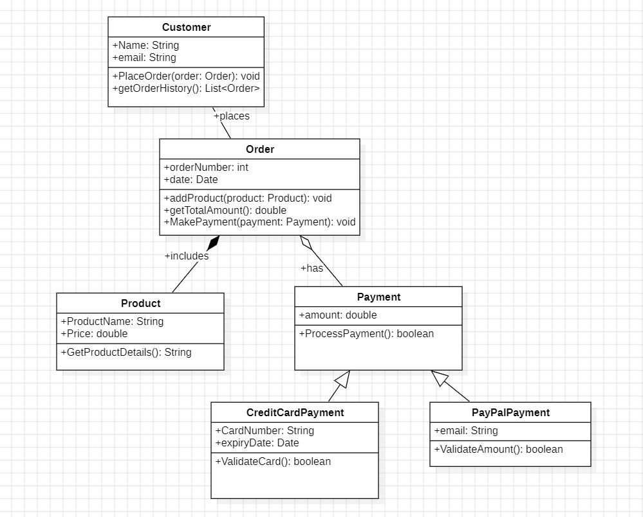

**2. University Management System:**

**Description: Design a class diagram for a university management system that includes**

**students, courses, professors, and departments.**

**Relationships:**

**A Student can enroll in multiple Courses (association).**

**A Course is taught by a Professor (association).**

**A Professor belongs to one Department (aggregation).**

**UndergraduateStudent and GraduateStudent are specialized types of Student**

**(inheritance).**

**Solution:**

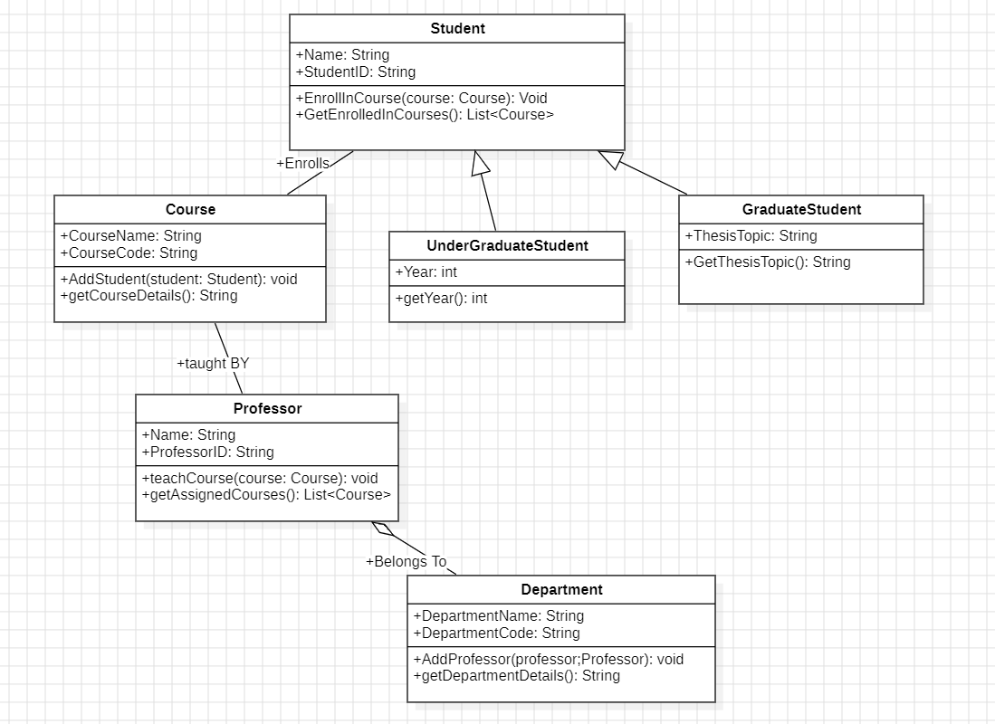

**3. Hospital Management System:**

**Description: Design a class diagram for a hospital management system that includes**

**patients, doctors, appointments, and medical records.**

**Relationships:**

**A Patient can have multiple Appointments (association).**

**A Doctor can have multiple Appointments with Patients (association).**

**An Appointment has one MedicalRecord (composition).**

**A Nurse assists a Doctor (association).**

**A Doctor can update MedicalRecords for Patients (association).**

**Solution:**

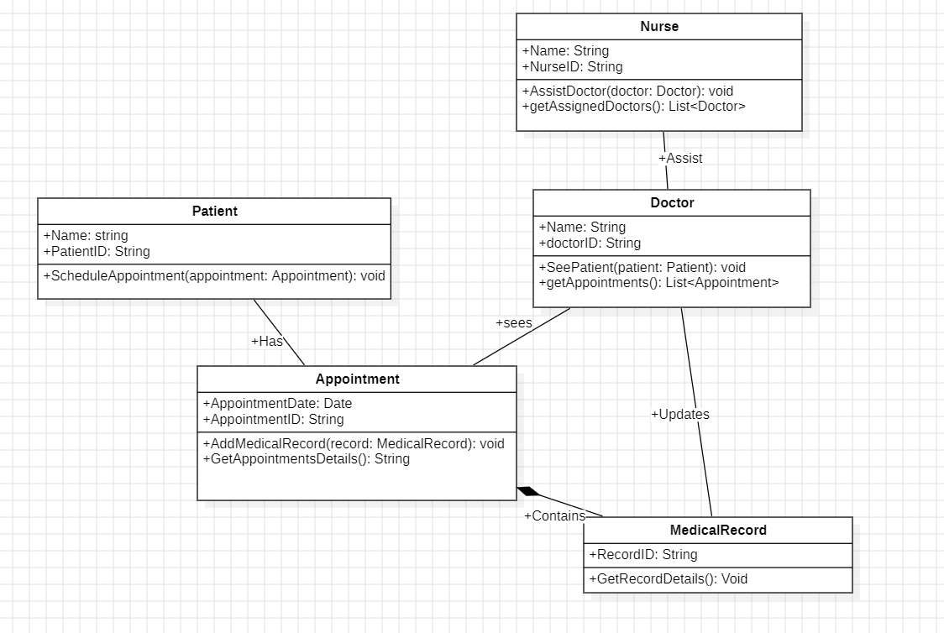

# **Practical/Lab No. 03**

Lab Tasks:

Task 1: Basic Deployment Diagram

Objective: Create a basic deployment diagram to understand the deployment of a single web application on a server.

Instructions:

1. Identify the following components:

o A web server (Node)

o A web application (Artifact)

o A client (Node) that accesses the web application

2. Draw a deployment diagram that includes:

o A node representing the web server.

o An artifact representing the web application deployed on the web server.

o A node representing a client machine that interacts with the web server.

Expected Outcome:

• A diagram showing a simple setup where a web application is deployed on a web server, and a client accesses it.

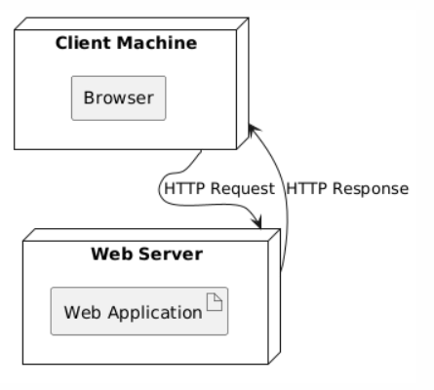

Task 2: Multi-Tier Deployment Diagram

Objective: Create a deployment diagram that represents a multi-tier architecture, including a web

server, application server, and database server.

Instructions:

1. Identify the following components:

o A web server (Node)

o An application server (Node)

o A database server (Node)

o A web application (Artifact) deployed on the web server

o A business logic application (Artifact) deployed on the application server

o A database (Artifact) deployed on the database server

2. Draw a deployment diagram that includes:

o A node for the web server with the web application artifact.

o A node for the application server with the business logic artifact.

o A node for the database server with the database artifact.

o Associations between the nodes showing the communication paths.

Expected Outcome:

• A diagram that illustrates a typical three-tier architecture, with clear communication paths between the web server, application server, and database server.

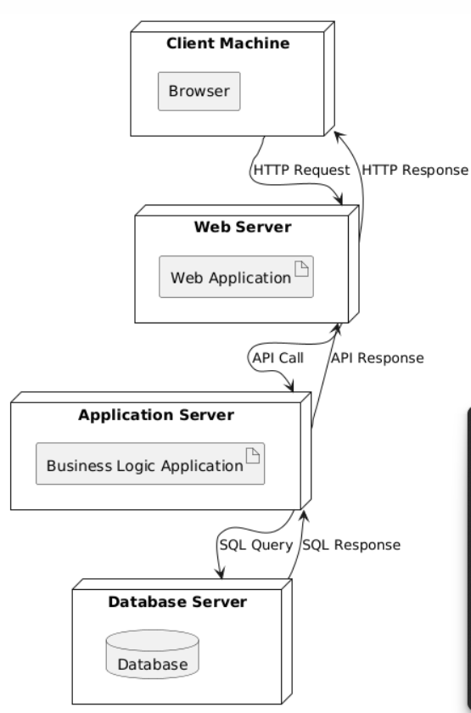

Task 3: Deployment Diagram with Dependencies

Objective: Create a deployment diagram that includes dependencies between artifacts deployed on different nodes.

Instructions:

1. Identify the following components:

o A web server (Node) o An application server (Node) o A database server (Node)

o A web application (Artifact) on the web server that depends on the application server.

o A business logic application (Artifact) on the application server that depends on the

database server.

o A database (Artifact) on the database server.

2. Draw a deployment diagram that includes:

o Nodes for the web server, application server, and database server.

o Artifacts for the web application, business logic application, and database.

o Dependency relationships between the artifacts showing how the web application

depends on the business logic application and how the business logic application depends on the database.

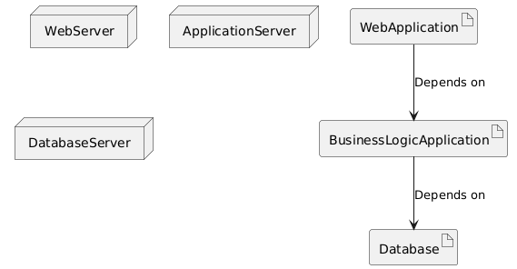

# **Practical/Lab No. 04**

Lab Tasks:

1. Create a state Transition diagram of Flight reservation and ATM process.

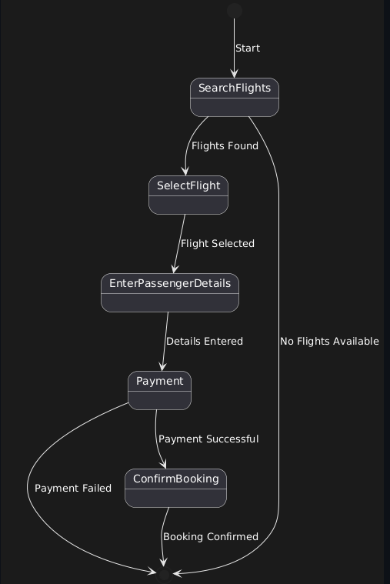

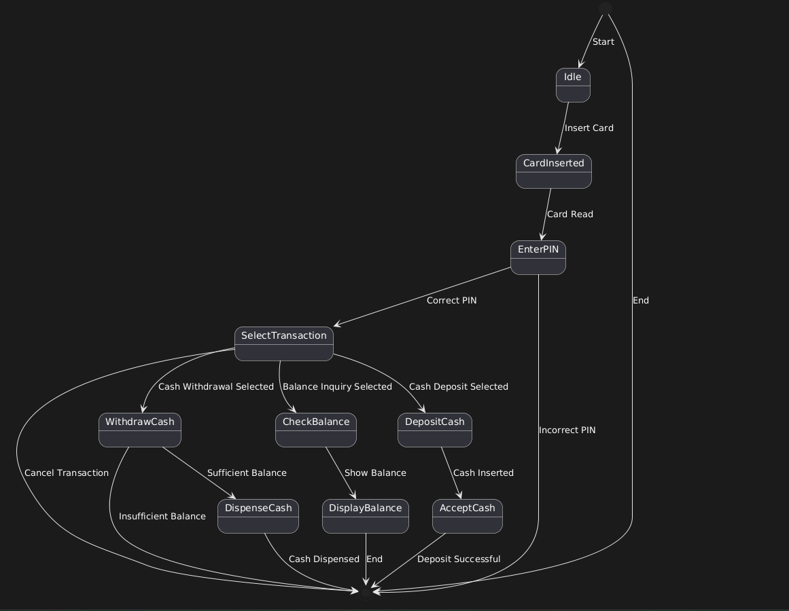

2. Create a state transition diagram for a coffee maker. The coffee maker has three states: idle, brewing, and warming. When the coffee maker is turned on, it transitions to the idle state. When a user selects the brew option, the system transitions to the brewing state and starts brewing coffee. Once the brewing is complete, the system transitions to the warming state to keep the coffee warm. If the user turns off the coffee maker, the system transitions back to the idle state.

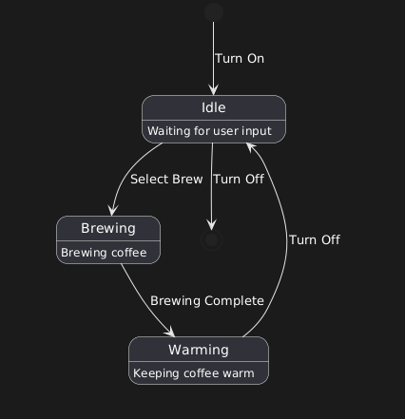

3. Create a state transition diagram for a game of tic-tac-toe. The game has two players and nine cells on the board. The game has three states: start, in progress, and end. When the game starts, the system transitions to the in-progress state. From there, the players take turns making moves until one player wins, the game ends in a draw, or a player forfeits the game. Once the game ends, the system transitions to the end state, where the user can choose to start a new game or exit the game.

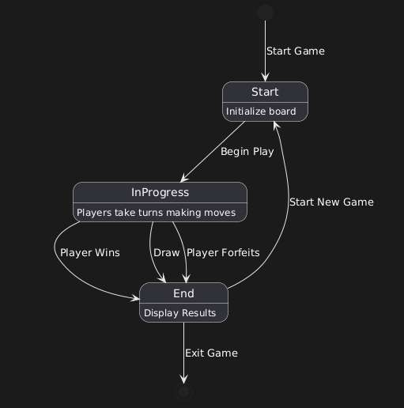

# **Practical/Lab No. 05**

Lab Tasks:

1. Create a sequence diagram that models the process of a customer placing an order on an e-commerce website. The diagram should show the interactions between the customer, the shopping cart, and the payment system, including the exchange of messages such as add item requests, update cart requests, and payment requests.

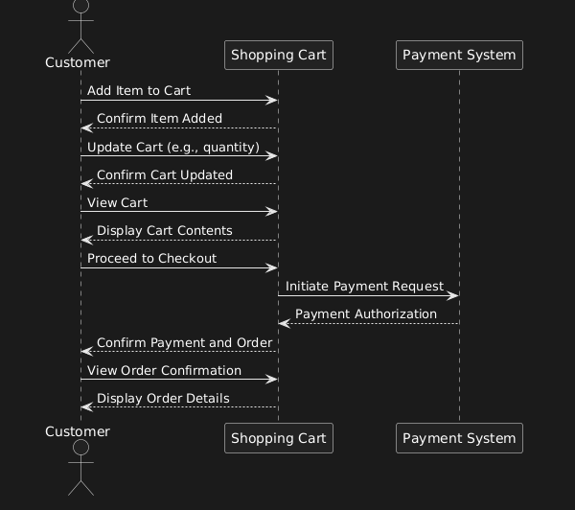

2. Create a sequence diagram that models the process of sending an email using a desktop email client. The diagram should show the interactions between the user, the email client, and the email server, including the exchange of messages such as login requests, compose email requests, and send email requests.

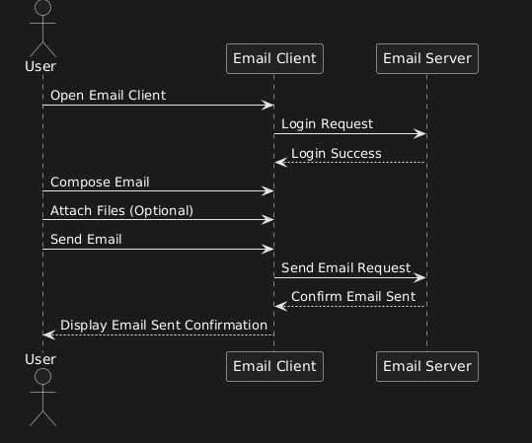

3. Create a sequence diagram that models the process of a customer booking a hotel room through an online reservation system. The diagram should show the interactions between the customer, the reservation system, and the payment system, including the exchange of messages such as search room requests, select room requests, payment requests, and confirmation responses.

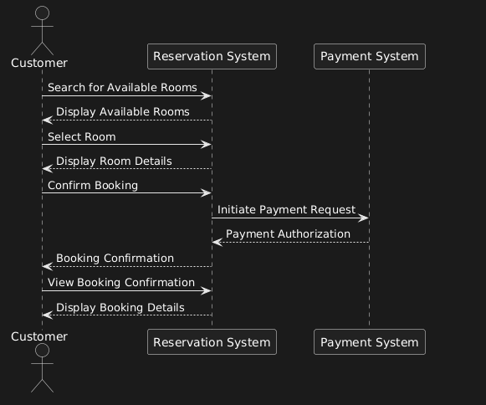

# **Practical/Lab No. 06**

Deployment diagrams.

**Task 1: Implement the singleton pattern in a class which returns database connections to the clients.**

|  |
| --- |
| public class DatabaseConnection {    // The single instance of DatabaseConnection    private static DatabaseConnection uniqueInstance;      // Private constructor to prevent instantiation from outside the class    private DatabaseConnection() {        System.out.println("Database connection established.");    }    // Public static method to return the instance of the class    public static DatabaseConnection getInstance() {        if (uniqueInstance == null) {            uniqueInstance = new DatabaseConnection();        }        return uniqueInstance;    }    // Method to simulate executing a query    public void executeQuery(String query) {        System.out.println("Executing query: " + query);    }    public static void main(String[] args) {        // Fetch the single database connection instance        DatabaseConnection dbConnection1 = DatabaseConnection.getInstance();        dbConnection1.executeQuery("SELECT * FROM users");        // Fetch the same instance again        DatabaseConnection dbConnection2 = DatabaseConnection.getInstance();        dbConnection2.executeQuery("SELECT * FROM products");        // Verify that both instances are the same        System.out.println(dbConnection1 == dbConnection2);  // Should print 'true'    }  } |
|  |

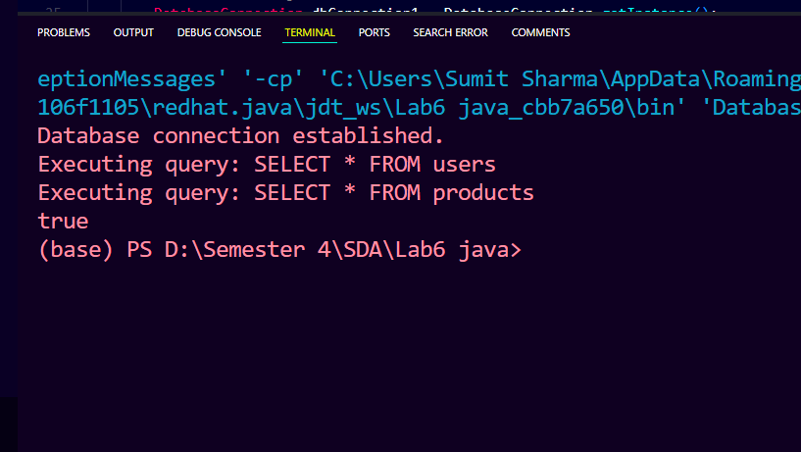

**Task 2: Create a Singleton class with a private constructor, a private static instance variable, and a public static method that returns the instance. Test the Singleton class by creating multiple instances and verifying that they are all the same object**

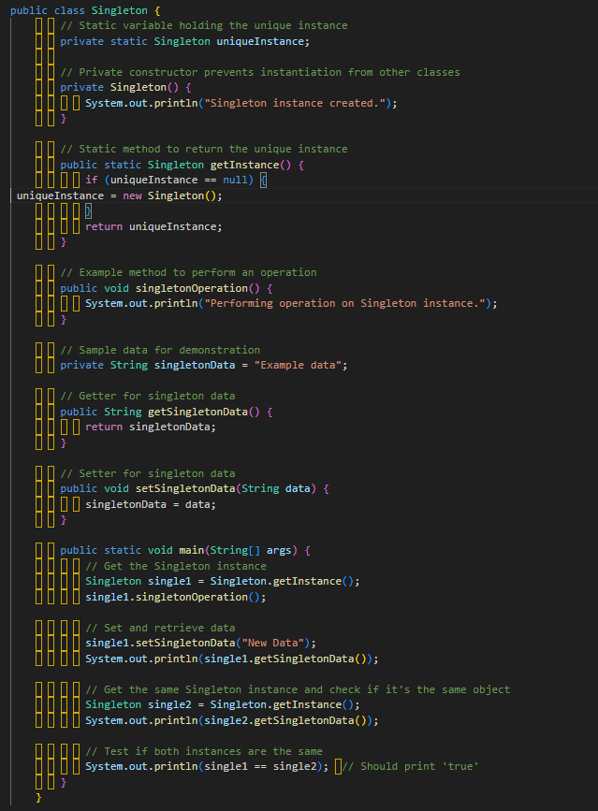

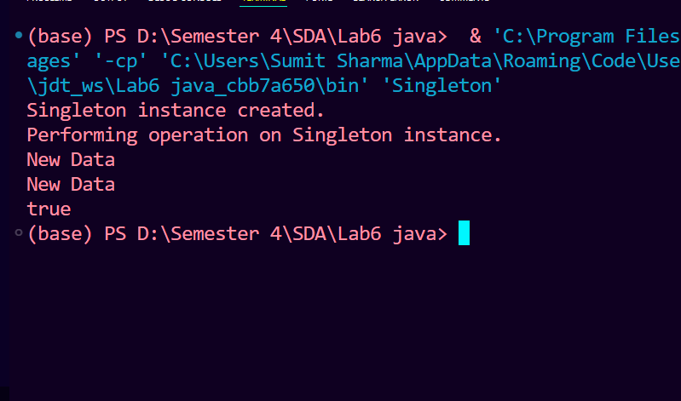

# **Practical/Lab No. 07**

To implement Abstract Factory Pattern

**Task 1:** Implement the Abstract Factory Pattern. Class diagram is given below:

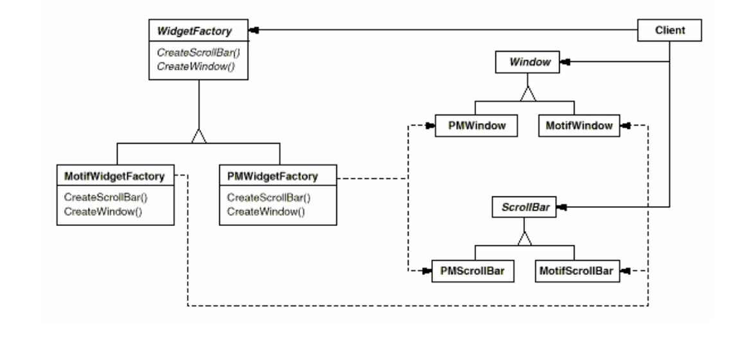

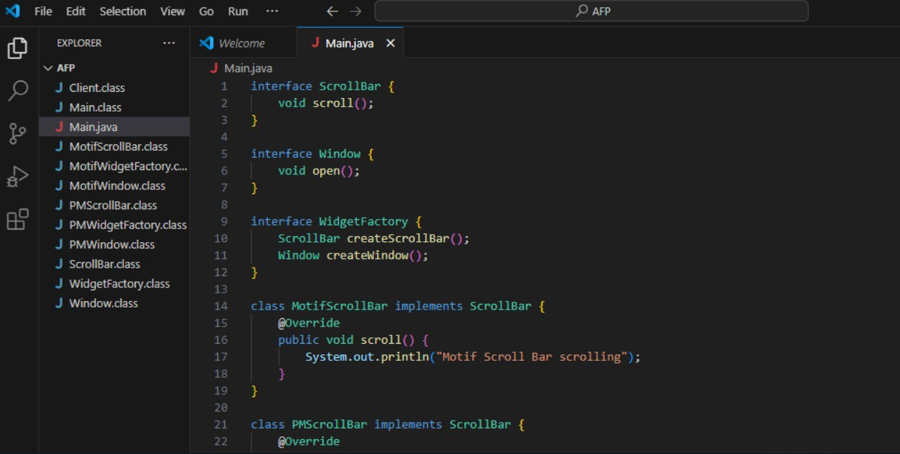

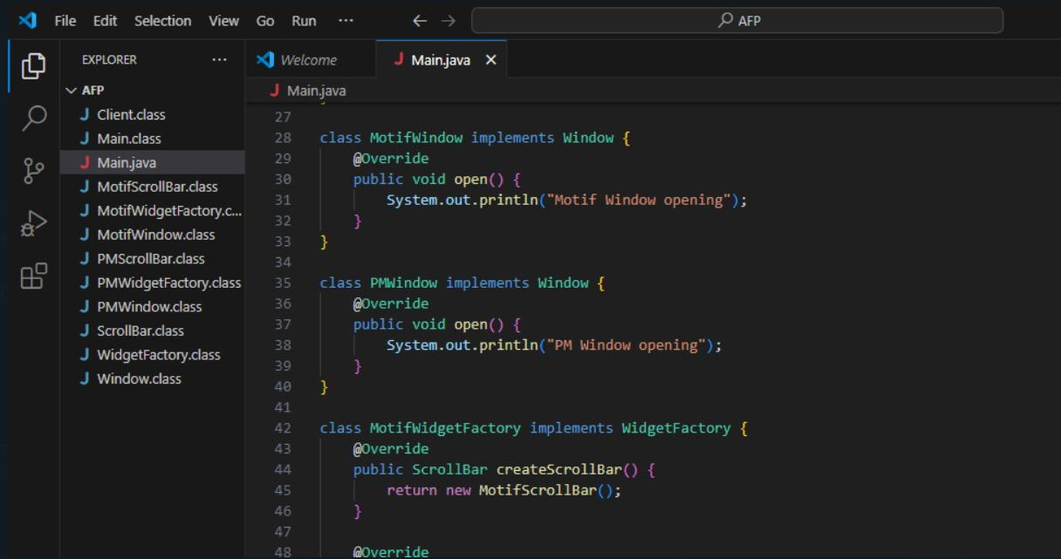

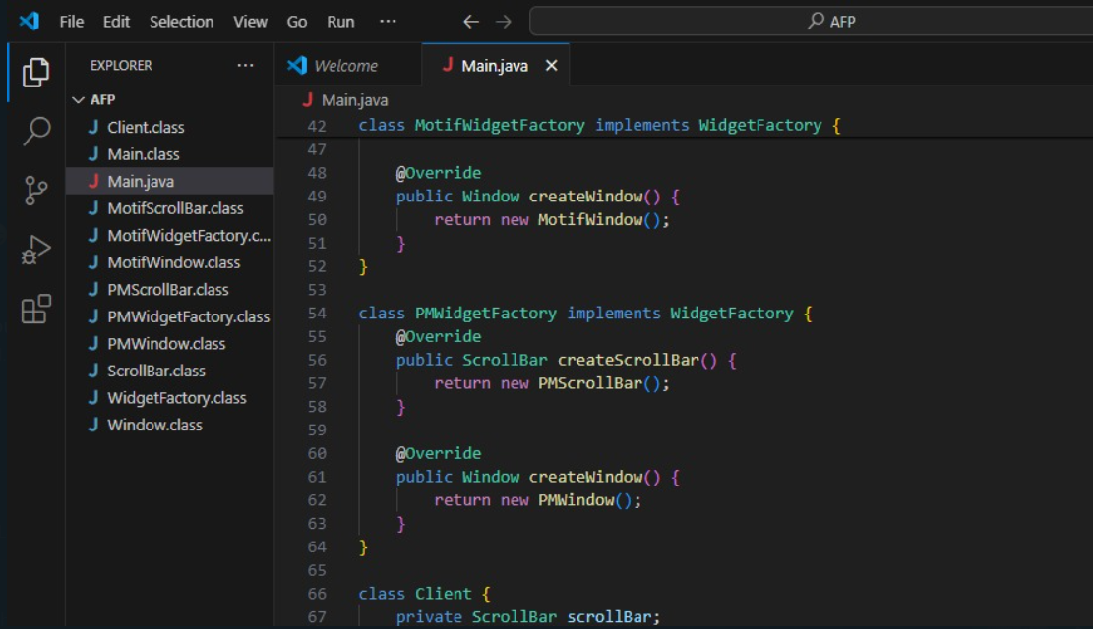

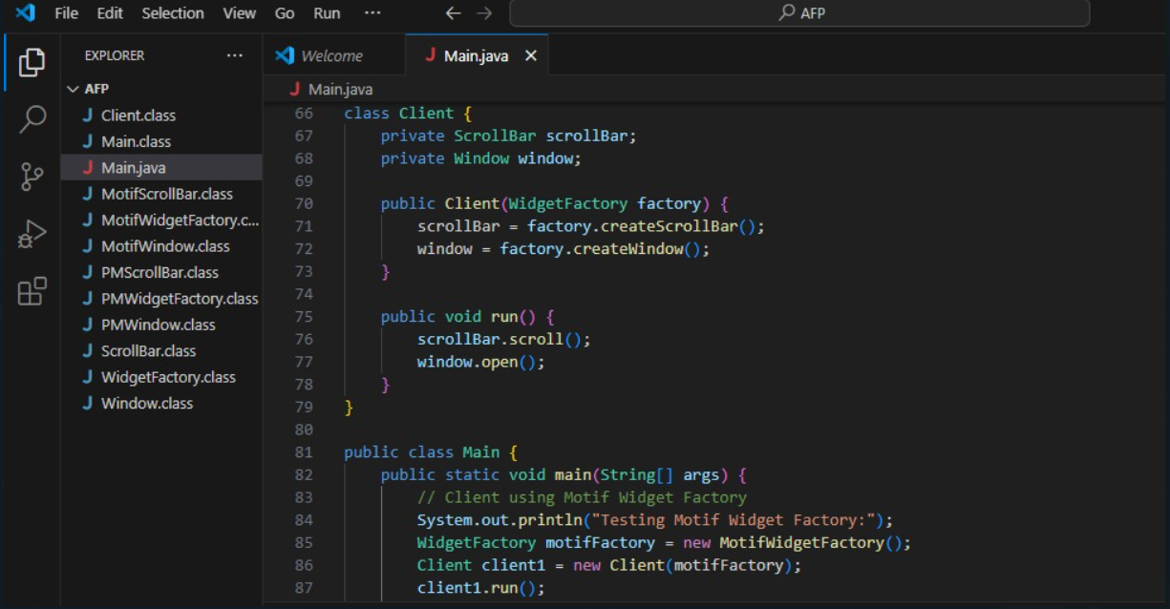

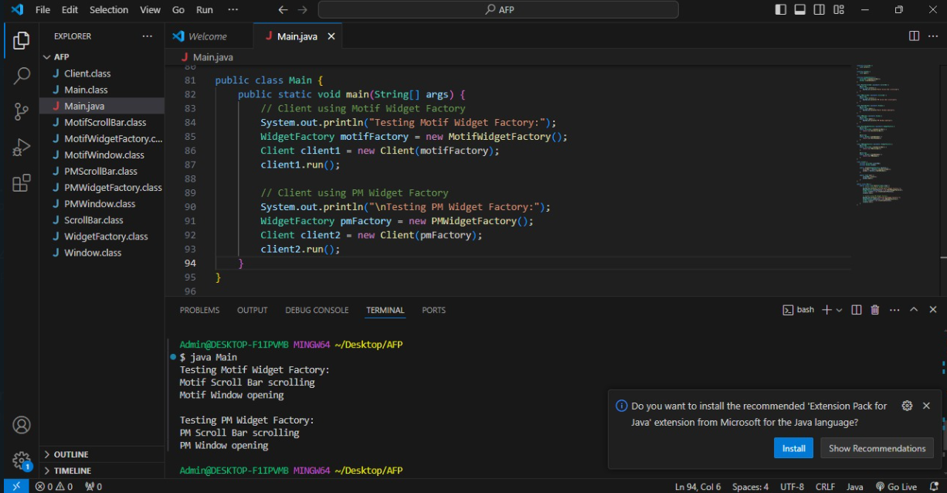

**Task 2:** Create a notification service through email, SMS, and push notification via the implementation of Factory Pattern.

**Code:**

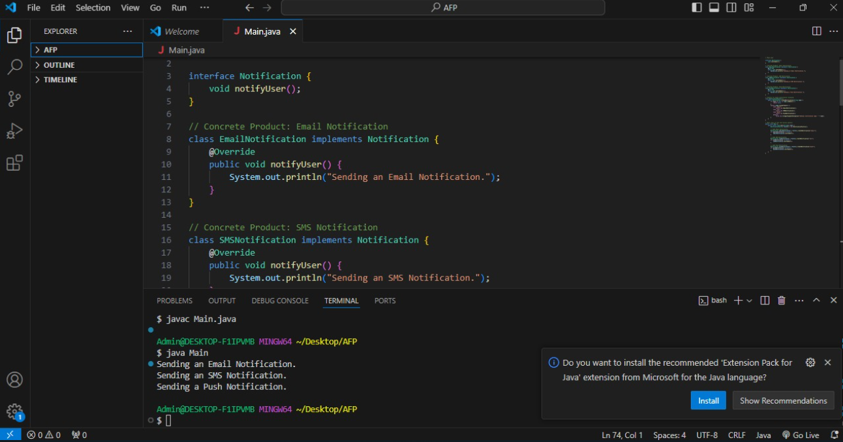

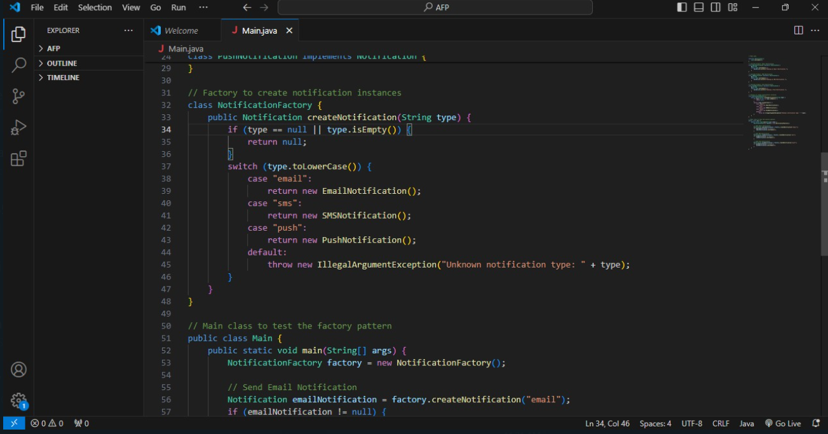

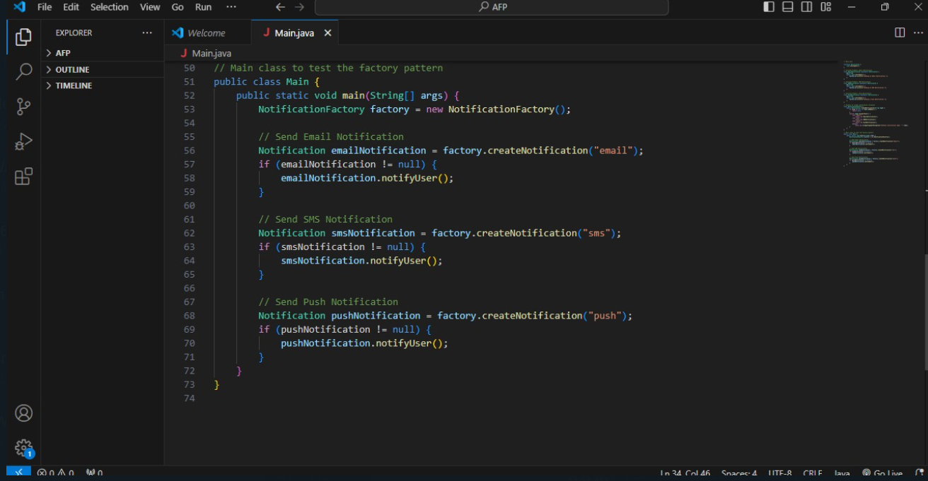

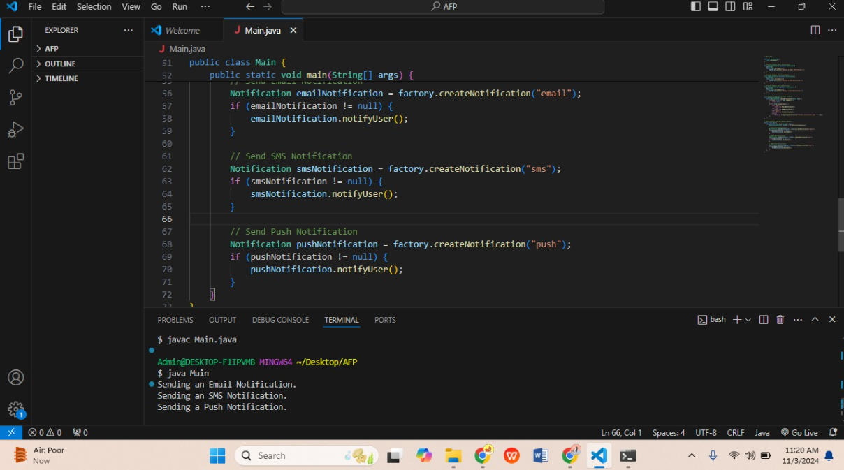

# **Practical/Lab No. 08**

To implement Adapter Pattern

**Task 1:** Implement an adapter class that can bridge the communication gap between two

incompatible classes. The adapter should wrap one of the classes and provide a compatible

interface that the other class can use to communicate with it.

**Code:**

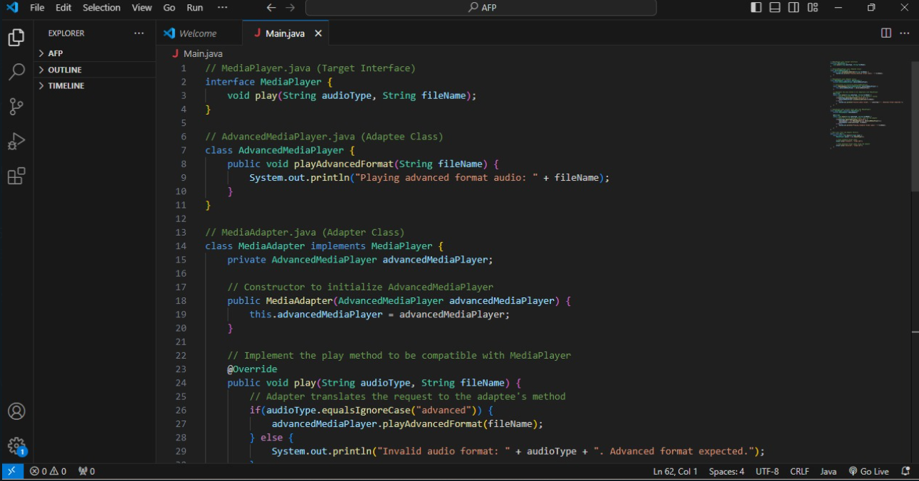

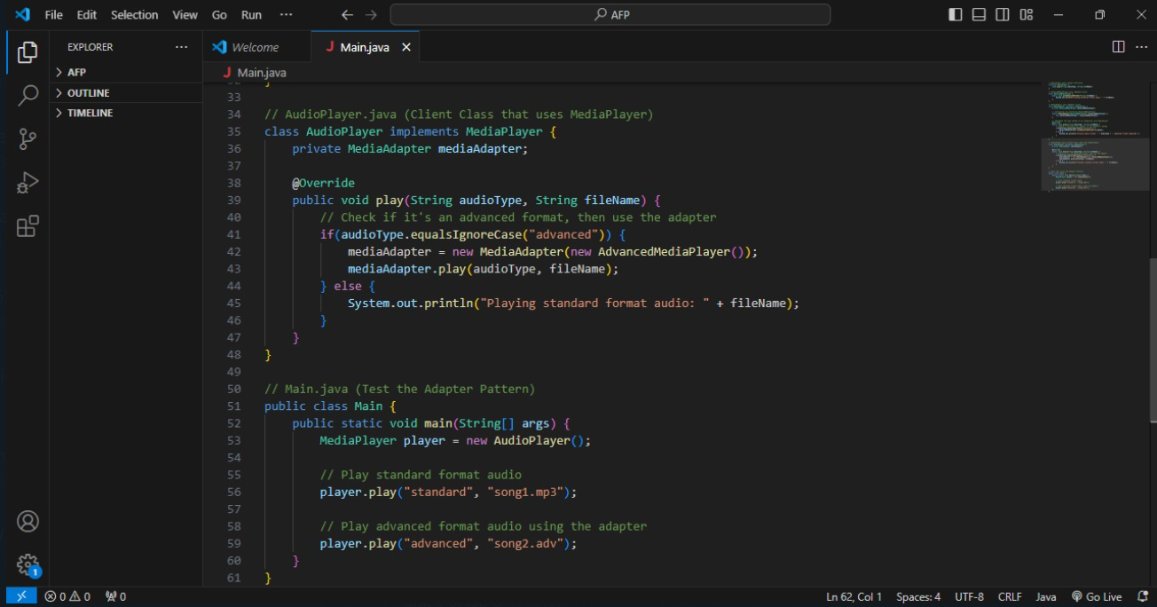

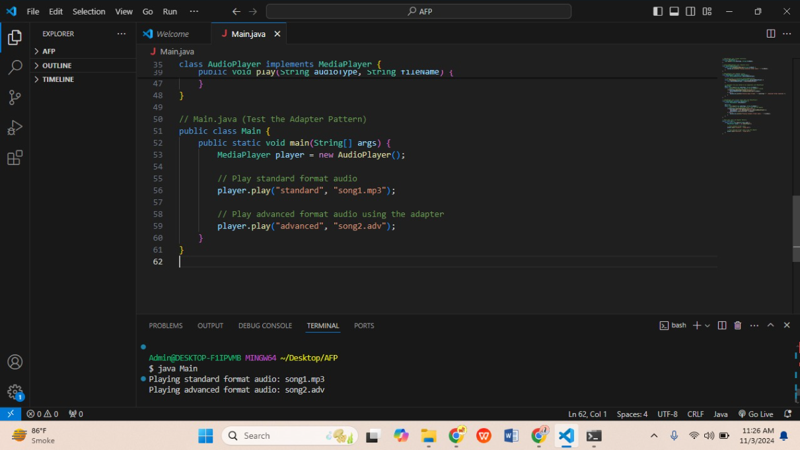

**Task 2: Create an adapter class that implements the new system&#39;s interface and wraps the existing class, modifying its methods as necessary to meet the new system&#39;s requirements. The adapter class should provide a compatible interface that the new system can use to communicate with the existing class.**

**Code:**

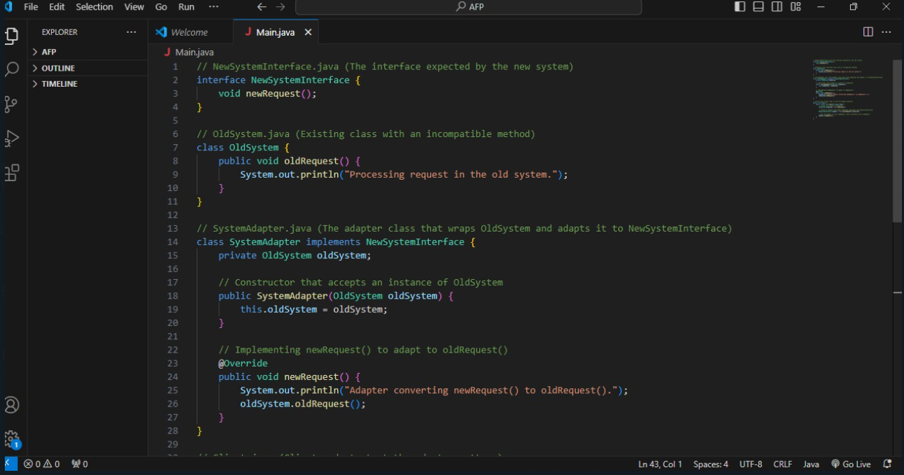

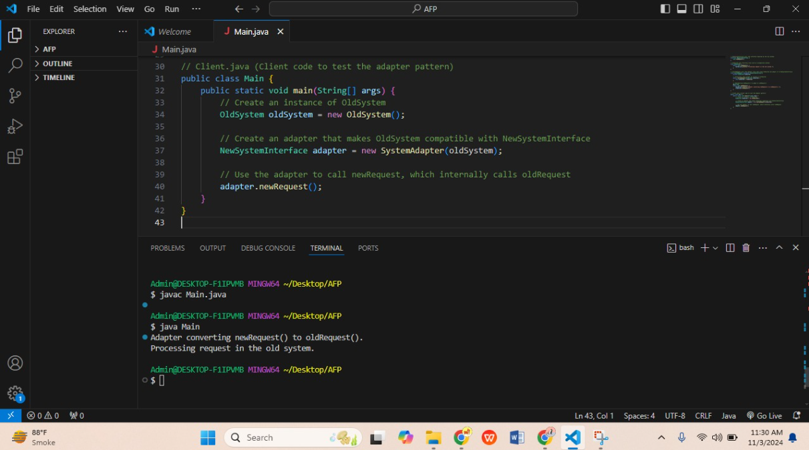

# **Practical/Lab No. 09**

To implement Decorator Pattern

**Task 1:** Develop an application for a pizza store by implementation of Decorator Pattern. Assume they offer four types of pizzas namely Peppy Paneer, Farmhouse, Margherita and Chicken Fiesta

**Code:**

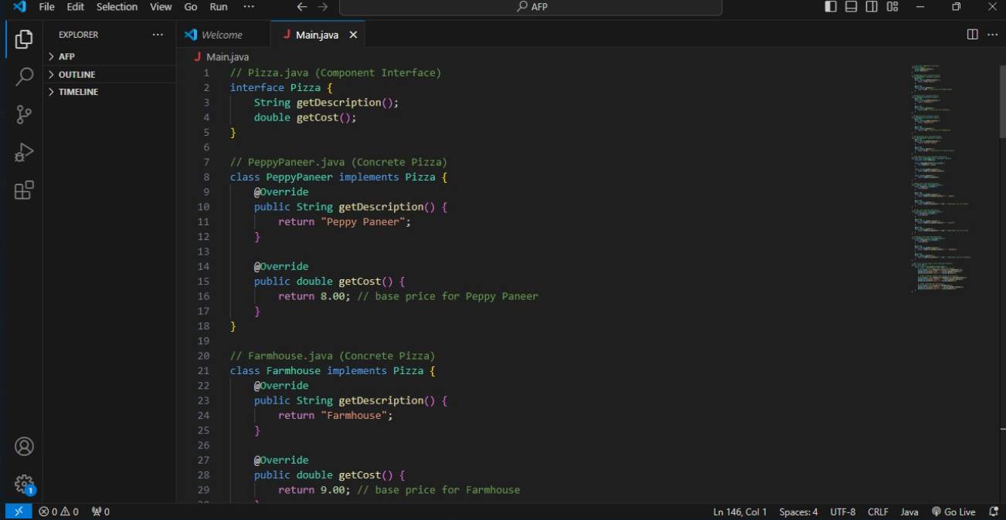

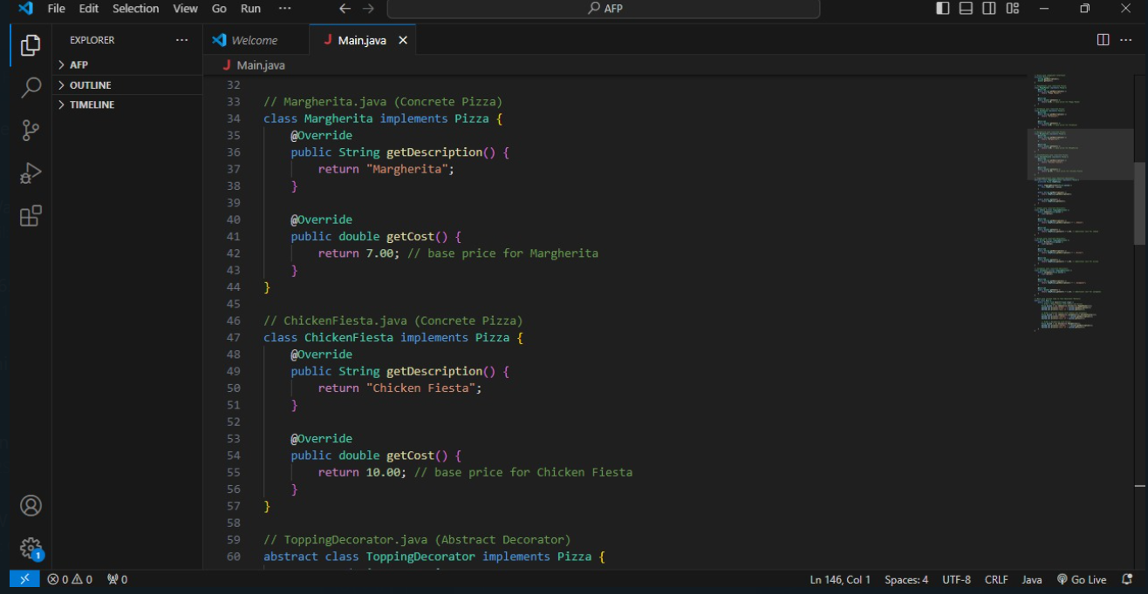

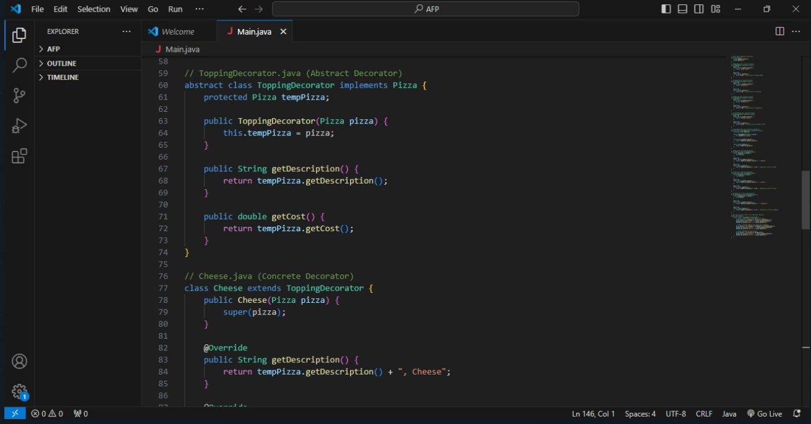

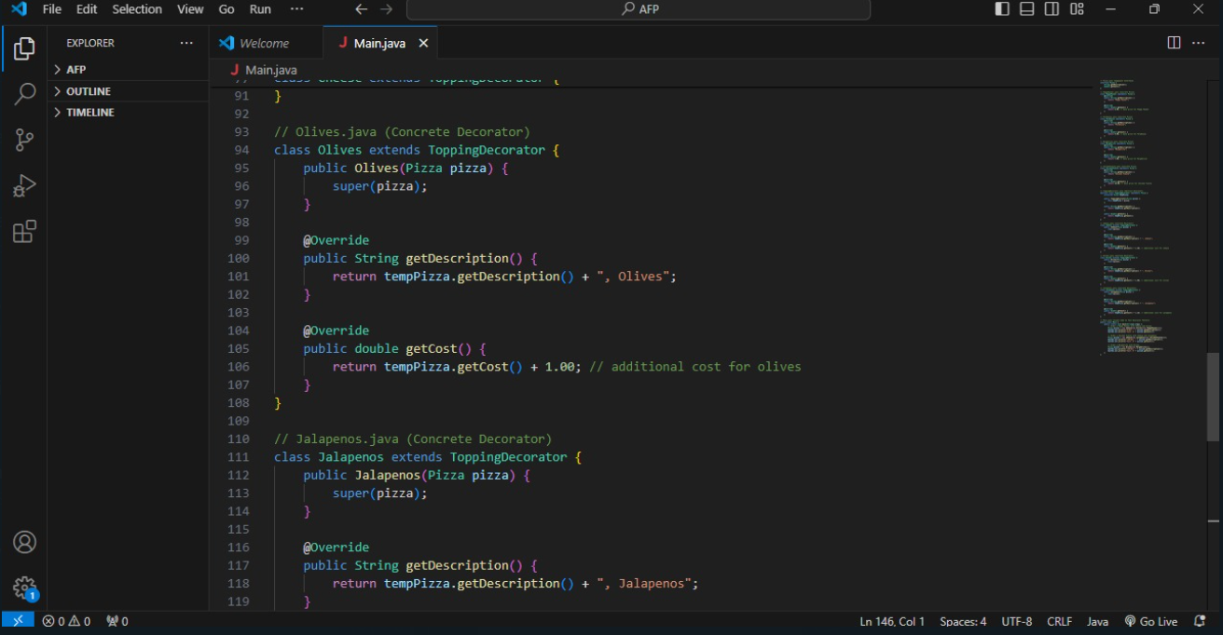

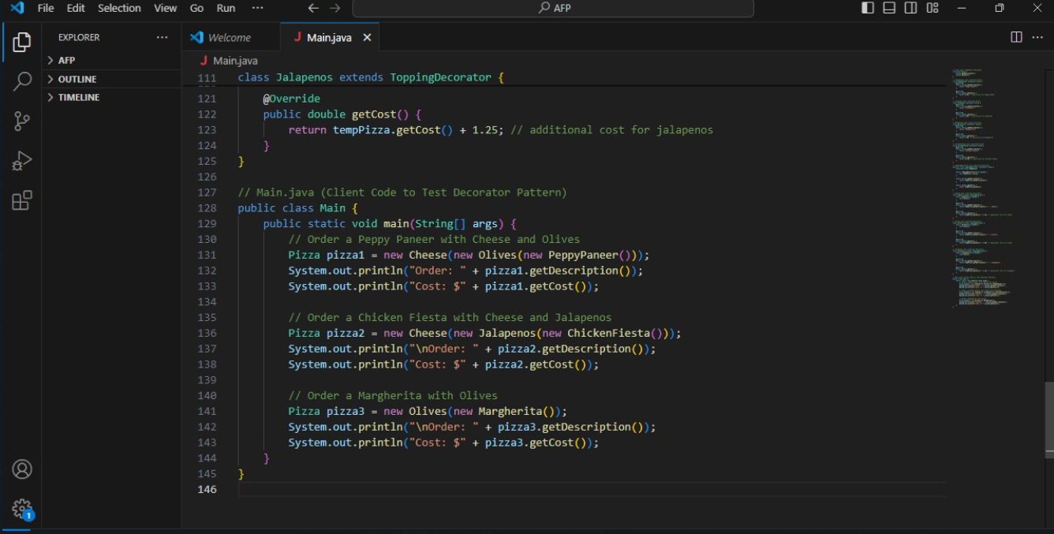

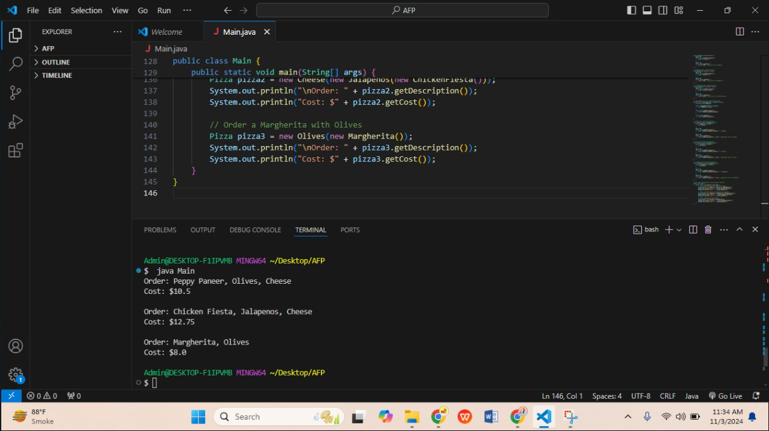

**Task 2:** Create a notification service through email, SMS, and push notification via the implementation of Factory Pattern.

**Code:**

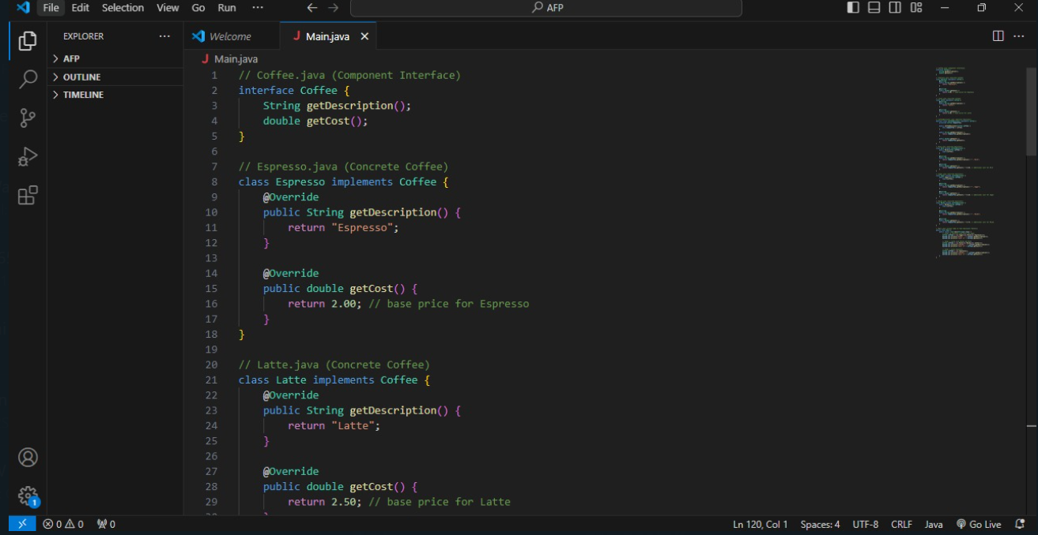

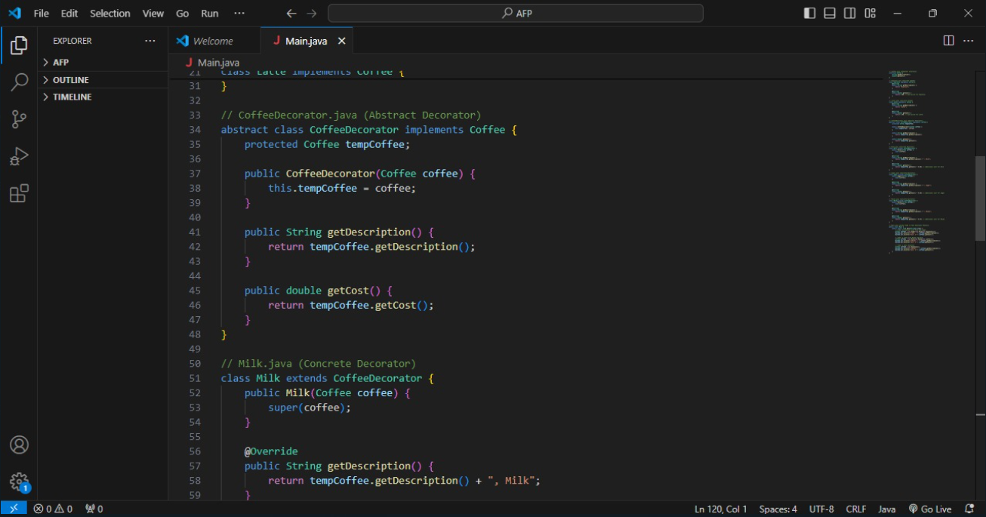

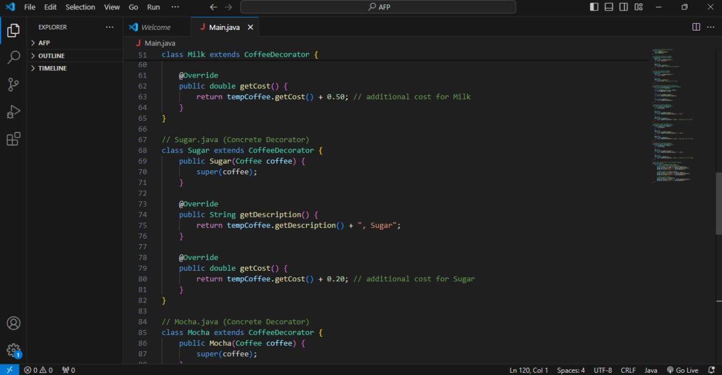

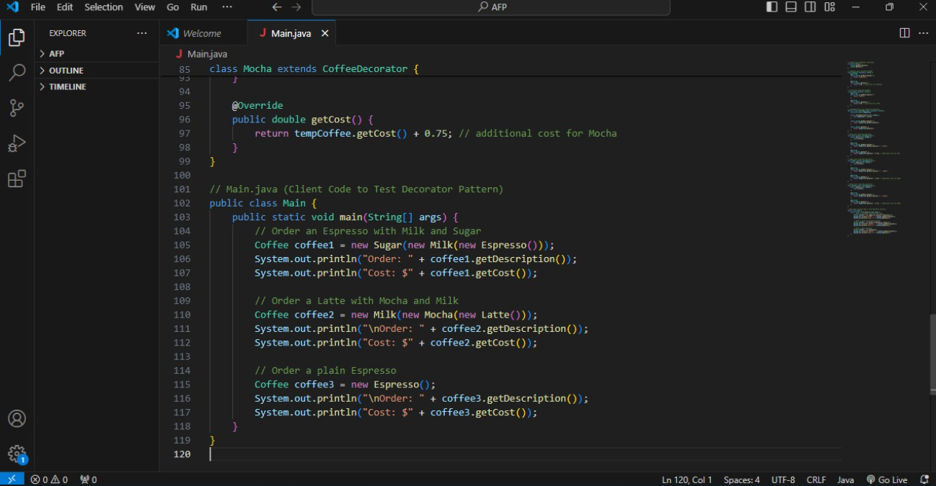

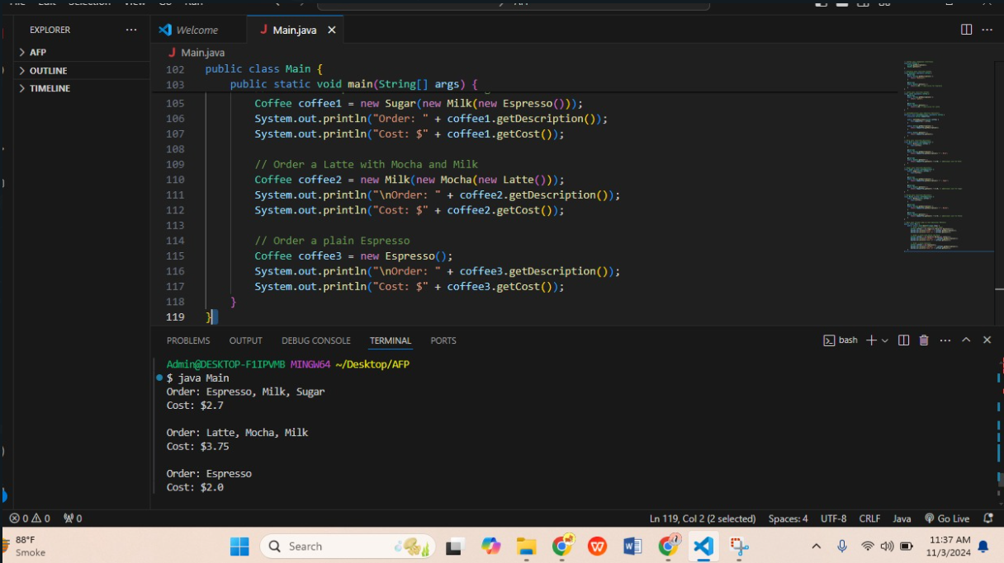

**Practical Lab#10**

**Lab Tasks:**

Task # 1: Create a notification system for an e-commerce website that sends out an email to

subscribers whenever a new product is added. The e-commerce website would be the &quot;subject&quot; and

the email subscribers would be the &quot;observers&quot;. Anytime a new product is added to the website, the

subject would notify all the subscribers and they would receive an email with details about the new

product.

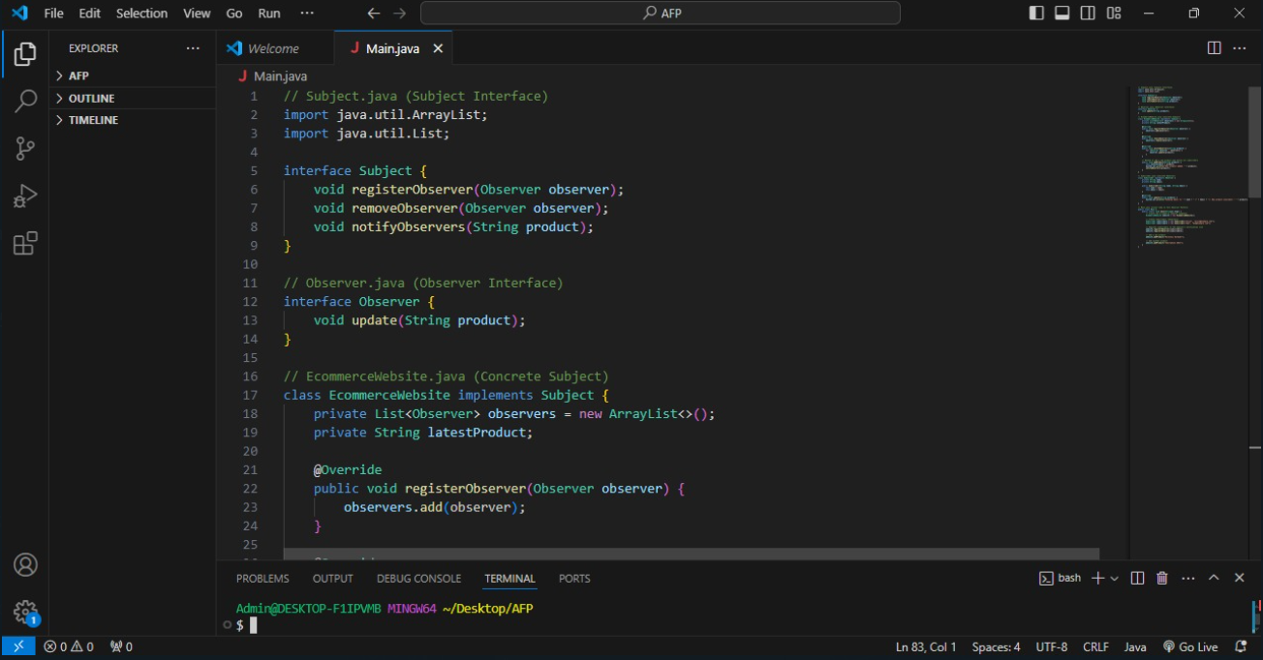

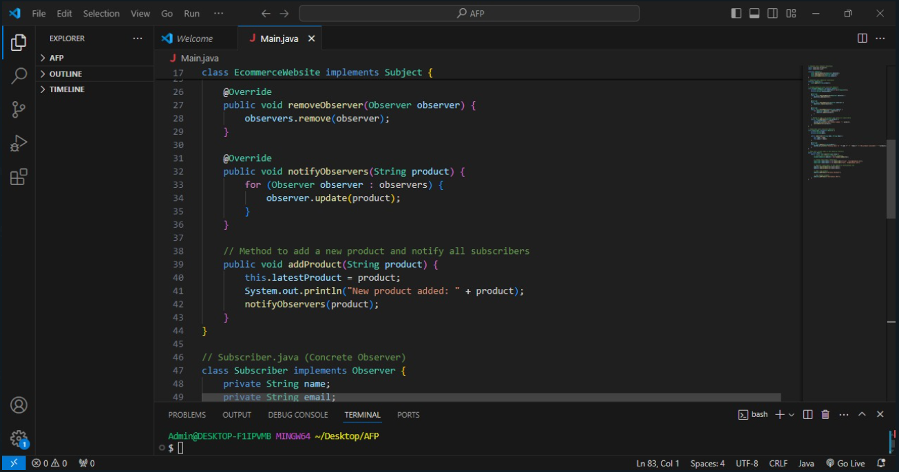

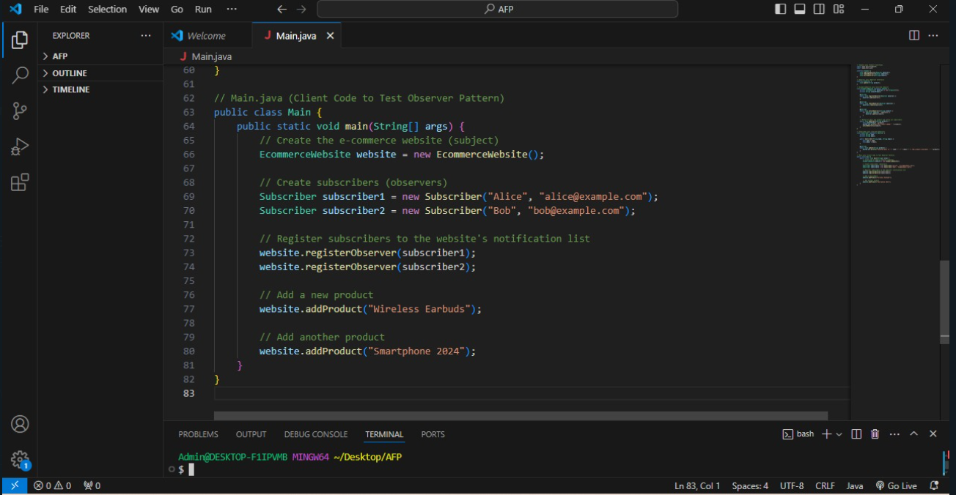

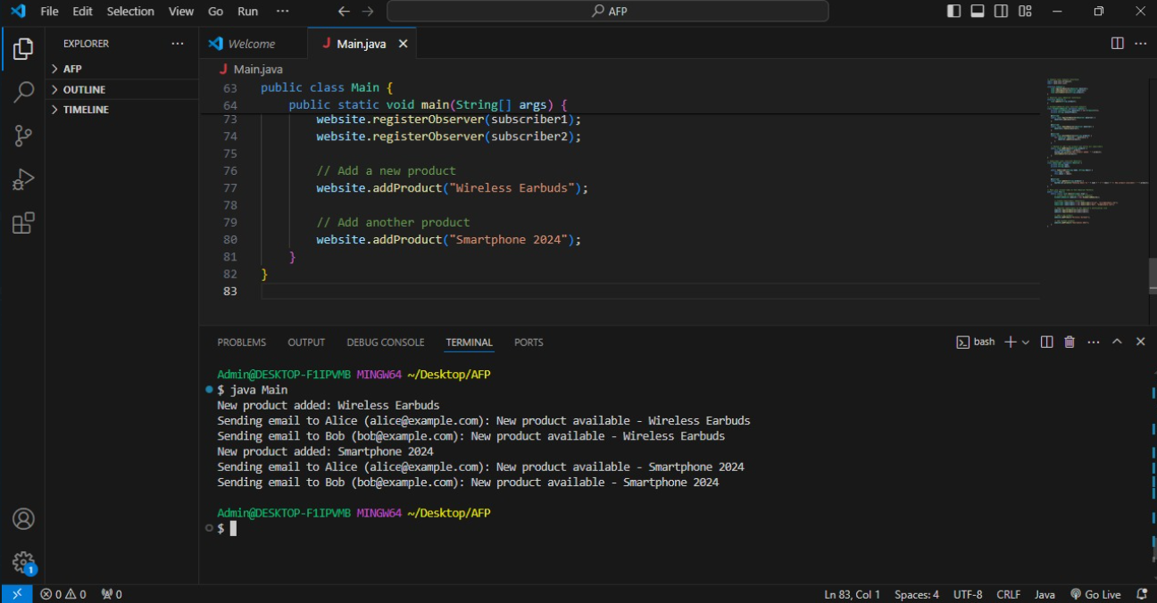

**Task # 2: Implement a messaging system for a chat application where users can subscribe to receive**

**notifications when a particular friend comes online. The chat application would be the &quot;subject&quot; and**

**the users would be the &quot;observers&quot;. Whenever a user&#39;s friend comes online, the chat application**

**would notify all the subscribers who have requested to be notified when that friend is available to**

**chat.**

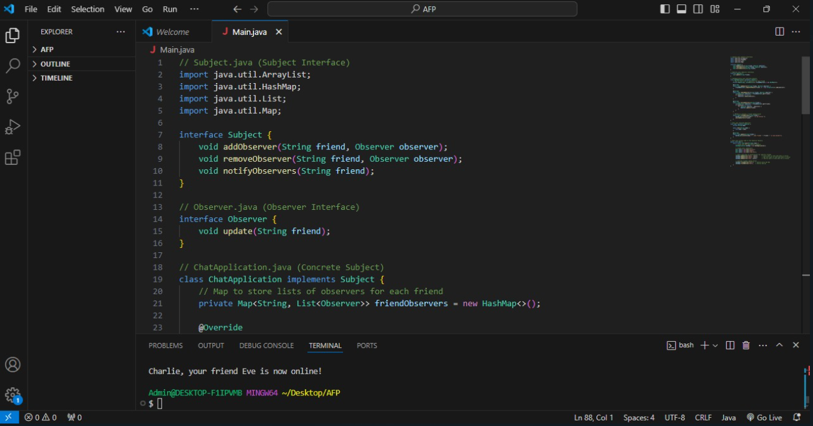

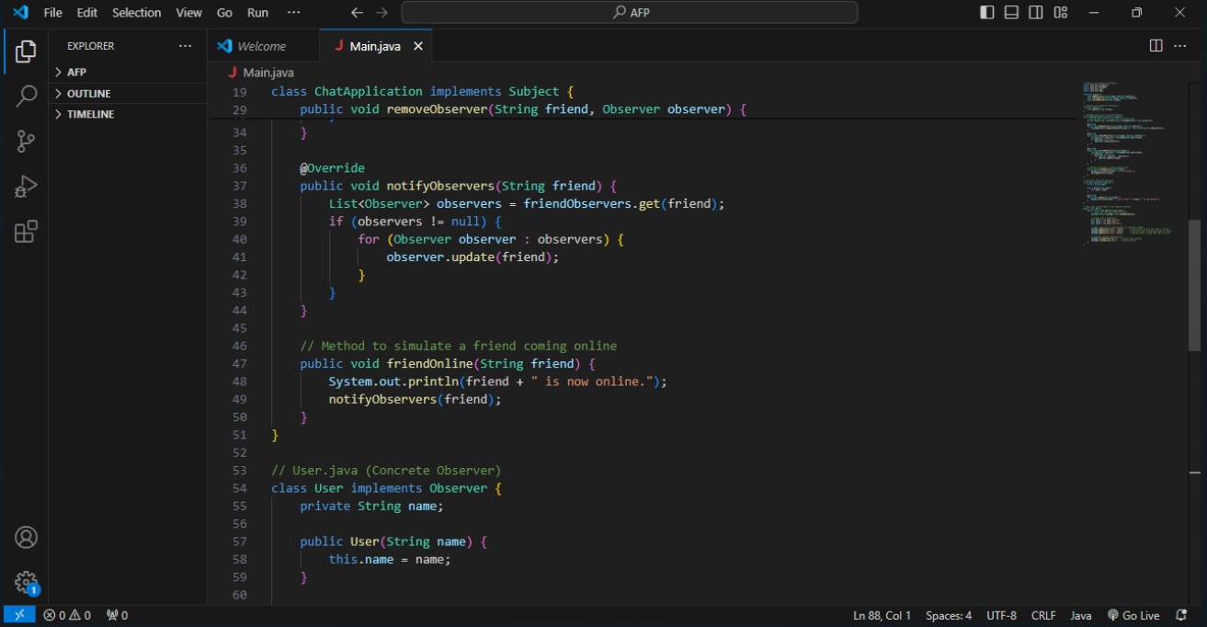

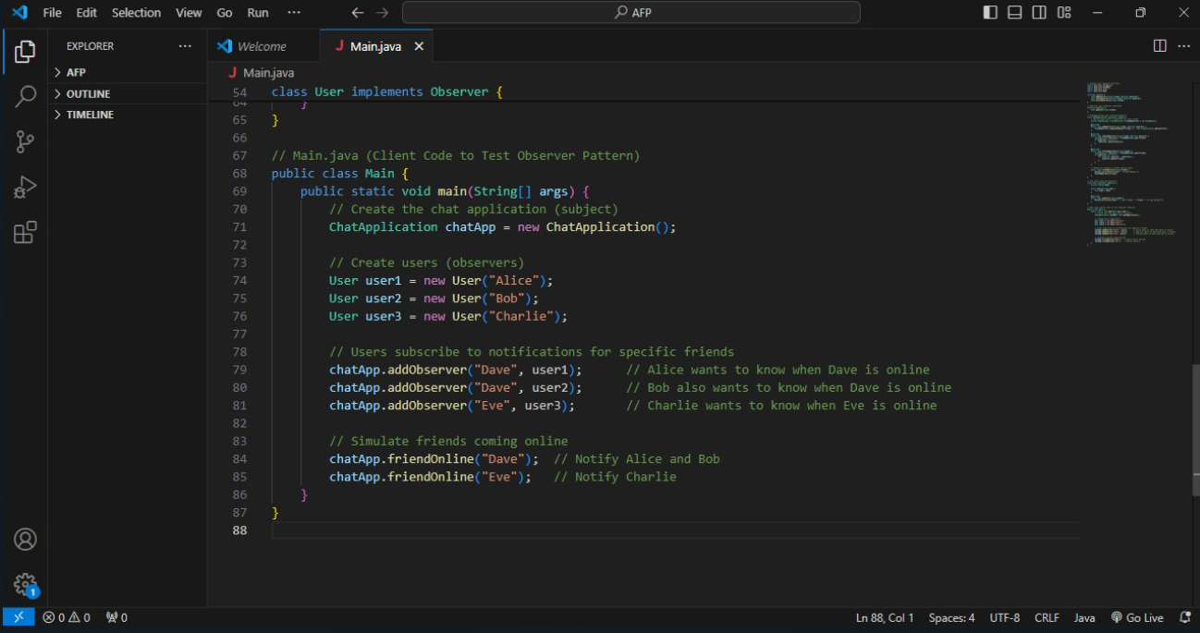

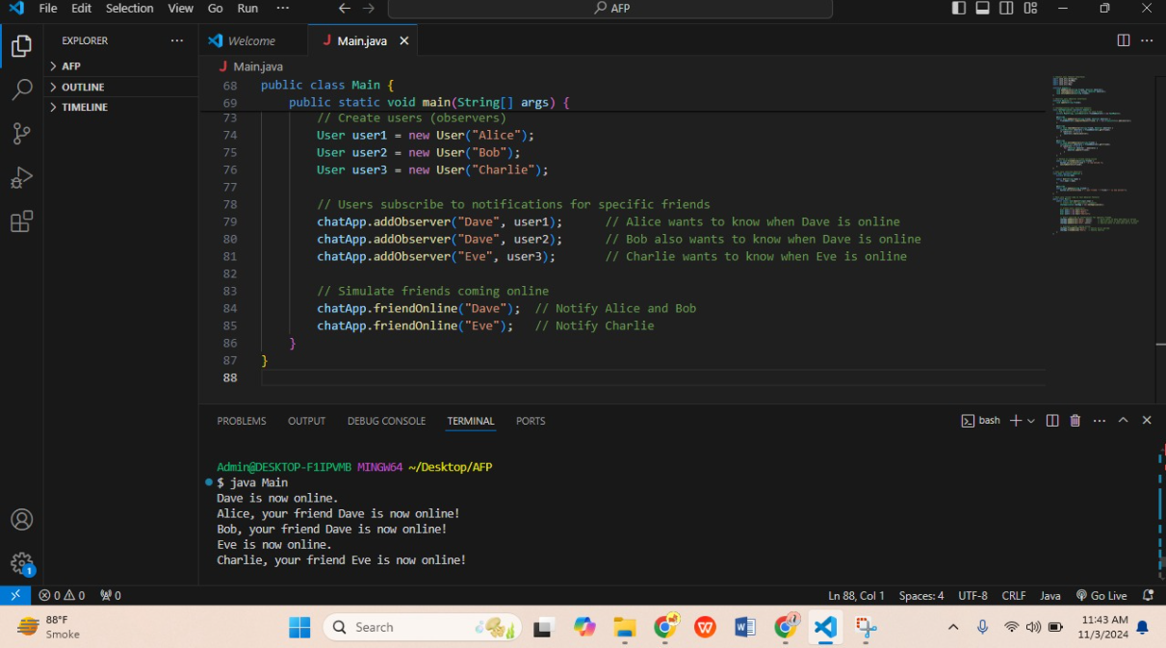

**Practical Lab#11**

**Lab Tasks:**

Task # 1: Implementing the Iterator Design Pattern for a List Data Structure.

• This task involves implementing the Iterator Design Pattern for a List data structure.

• It requires creating a List class that contains a private array to store the list elements and a public

method to add elements to the list.

• An Iterator interface should be created with methods to check if there are more elements in the

list and to get the next element. This interface should be implemented in a new class called

ListIterator, which will allow iteration through the list.

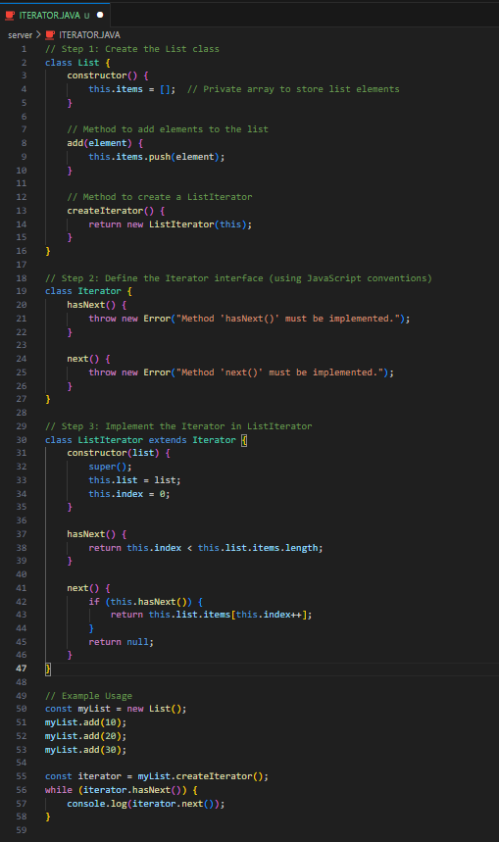

**output:**

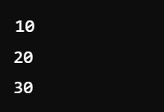

Task # 2: Using the Iterator Design Pattern to Traverse a Binary Tree.

• This task involves using the Iterator Design Pattern to traverse a binary tree.

• It requires creating a BinaryTree class that contains a root node and methods to add nodes to the

tree.

• An Iterator interface should be created with methods to check if there are more nodes in the tree

and to get the next node. This interface should be implemented in a new class called TreeIterator,

which will allow traversal through the binary tree. Different traversal algorithms such as Inorder,

Preorder, or Postorder can be used.

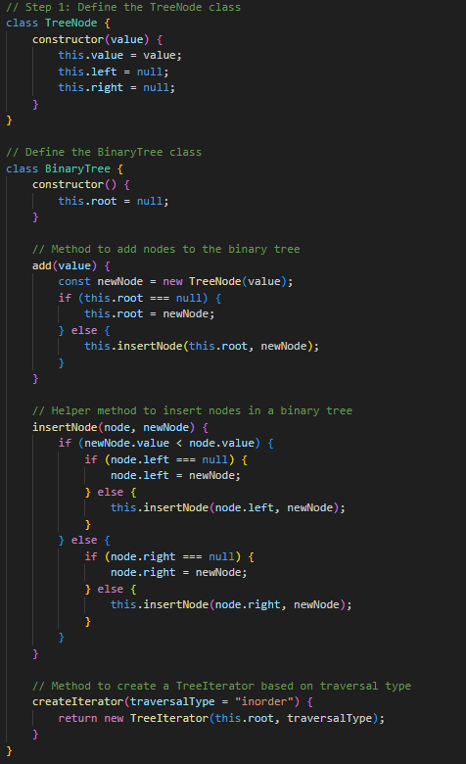

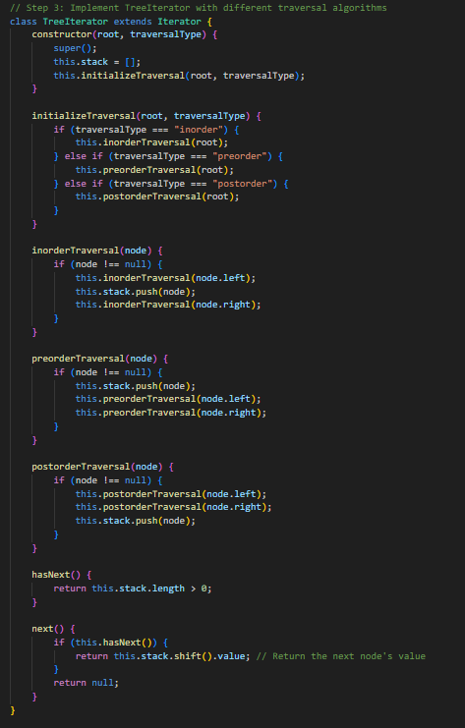

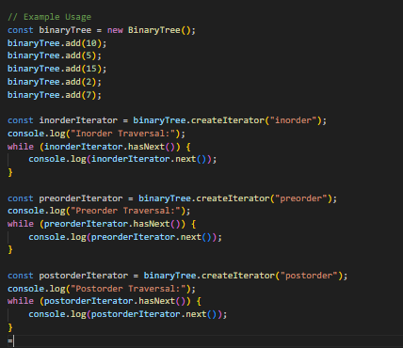

OUTPUT:

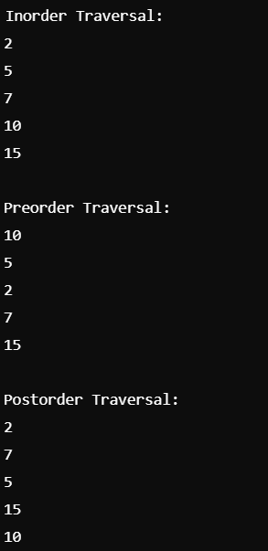

**Practical Lab#12**

**Lab Tasks:**

**Lab Task 1:**

Implement a system where users can pay using different payment methods such as Credit Card or

PayPal. The system should allow a shopping cart to handle multiple items and provide the flexibility

to choose a payment strategy at runtime. The goal is to dynamically switch between different

payments strategies without modifying the cart&#39;s structure.

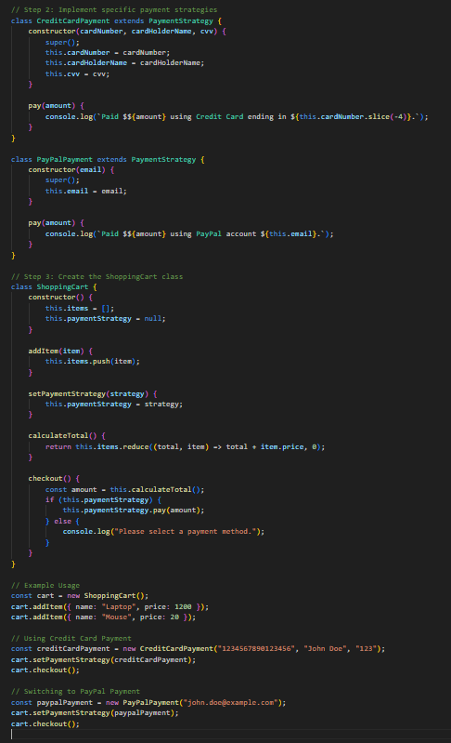

OUTPUT:

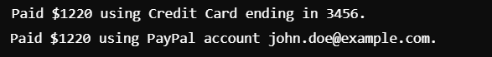

Lab Task 2:

Create a system where users can select different transportation modes like Car, Bike, or Bus to travel

to a destination. The system will allow the transportation method to be changed at runtime, enabling

flexibility and reusability without altering the travel context logic. You will demonstrate switching

between various strategies dynamically during the execution.

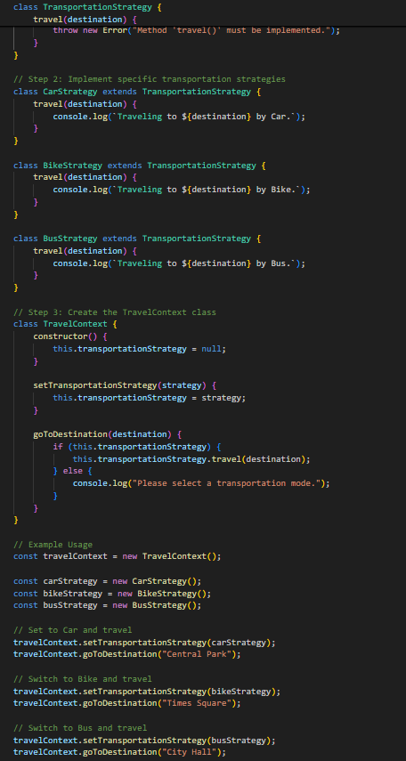

OUTPUT:

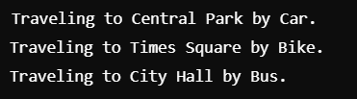

**Practical Lab#13**

**Lab Tasks:**

**1. Design CRC cards on any example system. (Describe the scenario first and then identify all**

**classes, make cards for just three of them with proper responsibilities).**

**Answer:**

### Scenario: Library Management System

**Scenario Description:** In a Library Management System, users can borrow books, return them, and pay any overdue fines. The system maintains a catalog of books with information about each book, such as title, author, and availability status. There are two types of users: library members who can borrow books, and librarians who manage the books and oversee library operations. The system also needs to manage loans to track the due dates and the status of borrowed books.

### Step 1: Identify Classes

Based on the scenario, the main classes identified are:

1. **Library**: Manages the library's operations, catalog, and handles users.
2. **Book**: Represents each book with its details (title, author, ISBN, availability).
3. **User**: Base class for Member and Librarian, containing common attributes like ID, name, etc.
4. **Member**: A user who can borrow and return books.
5. **Librarian**: A user who manages books in the catalog and oversees library functions.
6. **Loan**: Manages the loan record for each borrowed book, tracking member ID, book ID, and due date.
7. **Fine**: Tracks fines for overdue books and calculates amounts based on due dates.

We will create **CRC cards** for the Library, Book, and Loan classes.

### Step 2: Create CRC Cards

#### 1. **CRC Card for Library**

* **Class Name**: Library
* **Responsibilities**:
  + Manage catalog of books (add, remove, search).
  + Register new members and manage user data.
  + Process book loans and returns.
  + Calculate overdue fines and manage payments.
* **Collaborators**:
  + Book
  + Loan
  + Member
  + Librarian

#### 2. **CRC Card for Book**

* **Class Name**: Book
* **Responsibilities**:
  + Store book details (title, author, ISBN).
  + Maintain availability status (available, borrowed).
  + Searchable attributes (title, author).
* **Collaborators**:
  + Library (to update catalog information and status).
  + Loan (to update availability upon loan creation).

#### 3. **CRC Card for Loan**

* **Class Name**: Loan
* **Responsibilities**:
  + Track loan details (member ID, book ID, due date).
  + Update loan status (active, overdue, returned).
  + Calculate overdue fine if the book is not returned on time.
* **Collaborators**:
  + Member (to associate loans with members).
  + Book (to check book availability and update status).
  + Fine (to calculate any overdue fines).

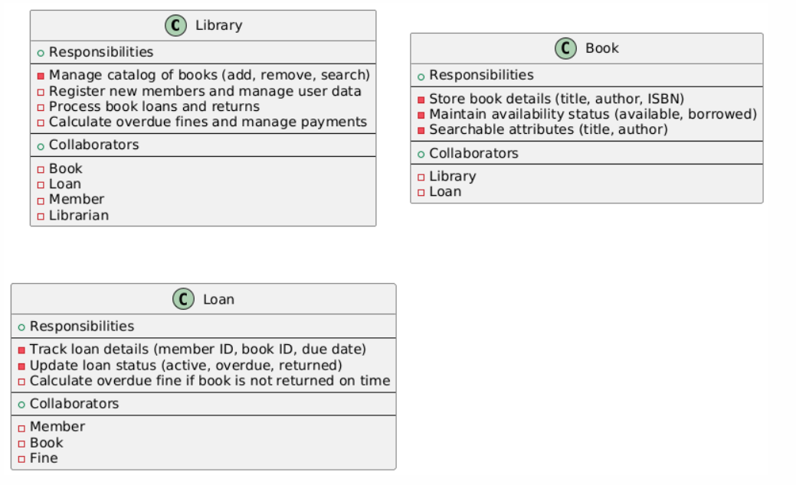

**2.Design a CRC model for a simple online shopping application. The application has a User**

**class, a Product class, and an Order class. The User class represents a user of the application,**

**the Product class represents a product that can be purchased, and the Order class represents an**

**order that a user places for one or more products.**

**Answer:**

### 1. **User Class**

* **Responsibilities**:
  + Maintain user account information (e.g., name, email, address).
  + Register and log in to the application.
  + Browse available products.
  + Place orders for products.
  + View order history.
* **Collaborators**:
  + Product (browsing products)
  + Order (placing and viewing orders)

### 2. **Product Class**

* **Responsibilities**:
  + Store product details (e.g., name, price, description, stock availability).
  + Update product information and inventory status.
  + Search and display product details.
* **Collaborators**:
  + User (viewing products)
  + Order (included in an order)

### 3. **Order Class**

* **Responsibilities**:
  + Create and manage order details (e.g., order ID, date, list of products, total amount).
  + Track order status (e.g., pending, shipped, delivered).
  + Calculate the total cost based on the products in the order.
* **Collaborators**:
  + User (associated with the user who placed the order)
  + Product (products included in the order)

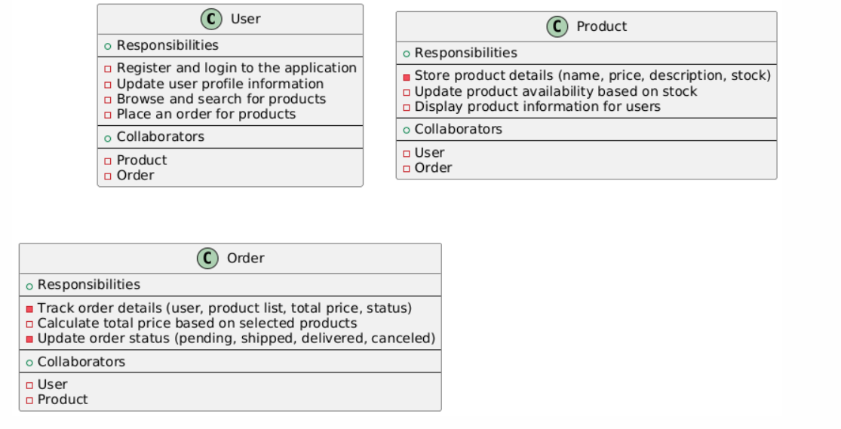

**Practical Lab#14**

**Lab Tasks:**

Write pseudocode for following:

1. “Read” the price of an item, take a 20% discount, and display the original price and the discounted price on the console.

**Answer:**

BEGIN

// Step 1: Read the original price of the item

DISPLAY "Enter the original price of the item:"

INPUT original_price

// Step 2: Calculate the 20% discount

discount = original_price * 0.20

// Step 3: Calculate the discounted price

discounted_price = original_price - discount

// Step 4: Display the original and discounted prices

DISPLAY "Original Price: ", original_price

DISPLAY "Discounted Price: ", discounted_price

END

**2.Input five strings from user, and print them in alphabetical order. (Just assume all strings start**

**with a different letter)**

Answer:

BEGIN

// Step 1: Initialize an empty list to store the strings

DECLARE string_list as LIST

// Step 2: Input five strings from the user

FOR i FROM 1 TO 5 DO

DISPLAY "Enter string ", i, ":"

INPUT user_string

ADD user_string TO string_list

END FOR

// Step 3: Sort the list of strings in alphabetical order

SORT string_list IN ALPHABETICAL ORDER

// Step 4: Print the strings in alphabetical order

DISPLAY "Strings in alphabetical order:"

FOR EACH string IN string_list DO

DISPLAY string

END FOR

END

**Practical Lab#15**

**Lab Tasks:**

1. Define an application of your choice and make a decision table for that application’s features.

Let’s consider an **Online Food Delivery Application**. This application allows users to browse restaurants, view menus, place orders, and make payments.

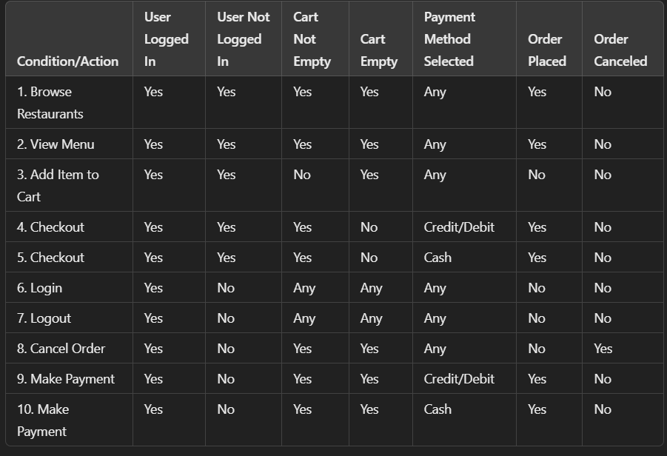

2. Create a decision table to determine whether a book is overdue or not based on the due date and checkout date. If the book was due more than 7 days ago, it is considered overdue. If the book was checked out less than 7 days ago, it is not overdue. If the book was due today and checked out today, it is not overdue. If the book was due in the past and checked out today, it is considered overdue.

